Event – Commodore’s Christmas Party & Annual Club Trophy Awards
So there it was …. the last Social Event of the Golden Jubilee Year! A good crowd of 25 members turned up to the Papercourt clubhouse to help eat and drink the Commodore out of house and home. We managed to do that with the special mulled wine, but the generosity of the extensive choice of mouth nibbles were too great for our number!
It should be noted too that some 12 usual attendees were absent. Covid, house sales, travel were all relevant factors, but with Christmas music in the background, and deafening chatter, the whole evening was still a fun celebration of friends catching up with each other. Christmas jumpers were much in evidence … at times it looked as if the ladies had all chosen the same bright red to colour match!
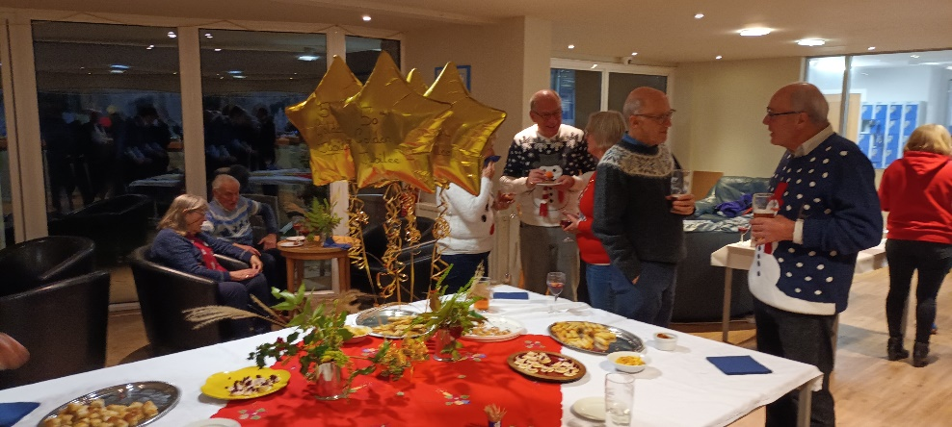
After nibbles were announced, and a suitable time period allowed for us to try them all and then have another one just to make sure (the honey and mustard cocktail sausages were just yummy!) the Commodore called for attention for the official business of the evening – the award of the Club Trophies.
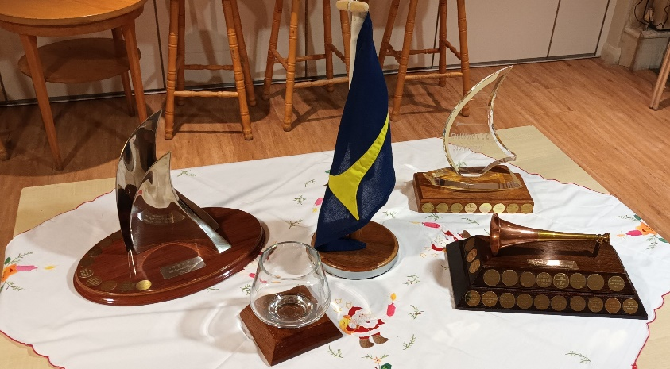
As you may recall, there are three Annual Trophies: The Greenhorn Trophy for the club member attending the most official rallies. A bit embarrassing, as Andrew said that he “hadn’t even been trying” – much to the amusement of several in the room, who recall his arduous beating against Force 7 waves, and choppy seas causing white water over the bows; and not on one rally, but several times, simply to get to a GCCC rally!!!!! Paul presented the trophy to Andrew, and jointly Margaret, because she had endured the conditions too!
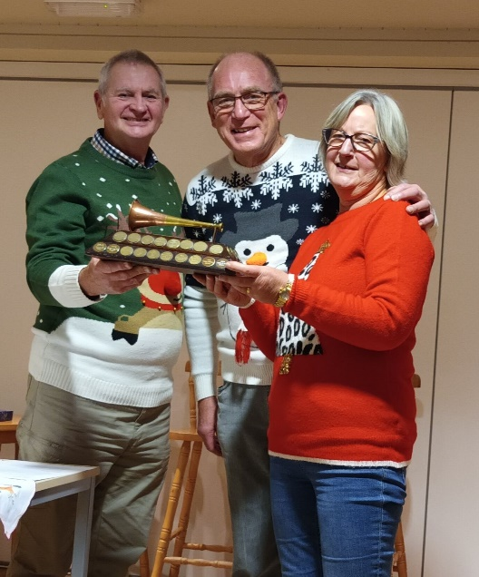
The Stowaway Trophy, for attending most rallies on other skipper’s club boats, was awarded to Martin & Jane Shott, sadly not able to make the evening. They will receive the trophy instead at the AGM in early January.
The Welcome Aboard Trophy for inviting the most stowaways on board a skipper’s boat was awarded to Chris & Denise Grainger, sadly not able to make the evening. They too will receive their trophy at the AGM.
The Bader Rose Bowl for an outstanding contribution to the club by a member was awarded to Sue Holder, a long-standing member, a past Membership secretary for many years, an outstanding event organiser, and a smiley happy character at all times. Well done Sue, and thank you for doing so much over the years to make the club such a success. Ron Moore, somewhat tentatively because it is glass, accepted the award on behalf of Sue, saying “I’ll drop it off on my way home”.
The Tom Edwards Trophy for an Outstanding Feat of Seamanship did not receive any nominations this year, and whilst the committee considered a few options (lobster pots on the summer Cruise, Andrew battling gales to get to rallies etc), it was ultimately decided it would stay in the cupboard this year.
Those who were there will tell you what an enjoyable and fun night it was. And of course, congratulations to all the Trophy winners, you will enjoy showing them off for the next year!

